**ITECH 7201**

**Assignment 2**

**Part B - Group Task**

**Human Resource Management System**

**Employee Management System**

**Leave Management System**

**Attendance Management System**

# Details of Team members

|  |  |  |  |  |
| --- | --- | --- | --- | --- |
| **Student ID** | **Name** | **Sub system responsible for** | **Contribution for Part B** | **Color code** |
| 30432670 | Syeda Tamanna Sheme | Employee  Management System | 33.34% |  |
| 30437681 | Tanvir Iqbal | Leave management System | 33.34% |  |
| 30423990 | Hansi Nipunika  Panwillaarachchi  Kotudura Bandanage | Attendance  Management System | 33.34% |  |

Table of Contents

Details of Team members 2

1. Introduction 4

1.1. System Scenario 4

1.2. Overview of Purpose 5

1.3. Overview of Scope 6

2. System Analysis and Design Background 7

3. Consolidated class diagram 7

4. Justification of Classes 10

4.1. Class Justification 10

4.2. Identify the subsystem for the attributes and classes 14

5. Codes for Class definition and method definition 16

# **Introduction**

The assignment involves developing a Human Resource Management System (HRMS) to centralize and automate HR functions such as employee management, leave management, and attendance management. In Part A, we focused on the Employee Management System, defining the system scenario and purpose, detailing its scope, and developing the domain model. This included creating classes like Employee, Supervisor, and HRManager, along with their relationships and functionalities. We also implemented code for key operations such as creating, updating, and viewing employee details. This work sets the foundation for integrating other subsystems into a comprehensive HRMS.

In this assignment, we will implement the system design created in the first assignment, focusing on our designated subsystems. Each team member will translate use case diagrams, class diagrams, and sequence diagrams into actual Java code for their subsystem. We will incorporate interface and inheritance implementation, as well as design patterns like singleton and state, to enhance the system's structure and efficiency. Additionally, we will develop comprehensive unit tests to validate the functionality of our subsystems and participate in a peer code review process to ensure code quality and adherence to standards. The implementation will be managed using GitHub, ensuring proper version control and collaboration within the team.

## **Functionality**

The HRMS (Human Resource Management System) Java project is organized following the Model-View-Controller (MVC) design pattern. It comprises several packages: hrms, hrms.boundary, hrms.control, hrms.entity, tests. The hrms package includes HardCodedData.java for static data. The hrms.boundary package defines interfaces for client interactions related to attendance, employee management, HRMS data, leave requests, and performance reviews. The hrms.control package contains the application logic, with classes like AttendanceControl.java, EmployeeControl.java, HRMSMain.java, LeaveRequestControl.java, and PerformanceReviewControl.java. The hrms.entity package consists of core data structures such as Attendance.java, Employee.java, LeaveRequest.java, LeaveType.java, PerformanceReview.java, and User.java. The tests package includes unit tests, maintaining a similar structure to the main application packages. Additionally, the project integrates JUnit 5 for testing, and a README.md file for documentation. There is also an ITECH7201 project/module in the workspace, containing source files for further coursework or exercises. This organized structure ensures a clear separation of concerns, facilitating maintainability and scalability.

The code in HRMSMain.java is part of a Human Resource Management System (HRMS) and is responsible for handling user login functionality. It includes importing necessary data, initializing lists for employees, attendance, and performance reviews, and setting up the main method to

prompt the user for a username and password. The login method checks the entered credentials against hardcoded user data, printing a success message and displaying the main menu if the login is successful, or an error message if the login fails.

The code in HRMSMain.java successfully implements the login functionality for the Human Resource Management System (HRMS). Upon execution, the program initializes necessary data, including users, employees, attendance records, and performance reviews. The user is prompted to enter a username and password, which are then validated against hardcoded user data. If the credentials are correct, the system grants access and displays the main menu with options to view employee details, attendance, leave, performance reviews, and an option to log out. If the credentials are incorrect, an error message is displayed, prompting the user to try again. The code ensures that the login process is handled securely and efficiently, providing appropriate feedback to the user based on the outcome.

In the first screenshot, the console output shows a failed login attempt with the username lm1 and password bb, resulting in the message "Invalid username or password. Please try again." In the second screenshot, a successful login attempt is made with the username lm1 and password x, resulting in the message "Login successful." This is followed by the display of the main menu options, allowing the user to choose from various HRMS functionalities.

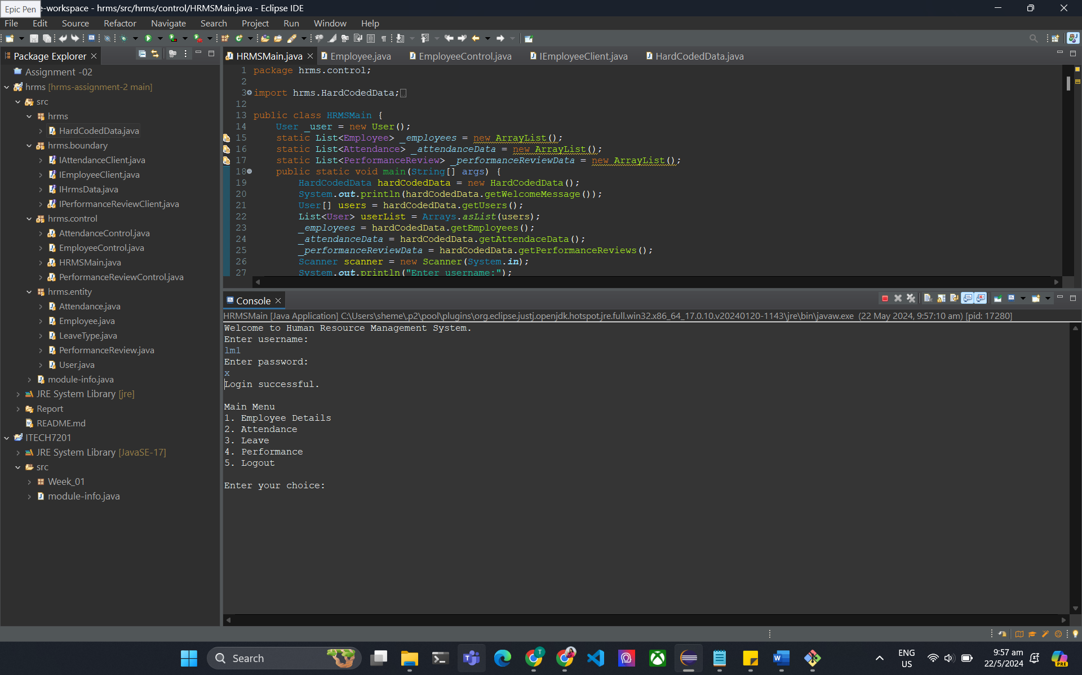

**Overview of Employee Details Functionality**

The provided screenshots display the functionality of an Employee Details module within a Human Resource Management System (HRMS). This module allows users to access detailed information about employees. The main menu offers several options, including viewing Employee Details, Attendance, Leave, Performance, and Logout. When the "Employee Details" option is selected, a sub-menu is presented, enabling the user to view details for "Self," "Subordinate (All)," "Subordinate (Employee)," or go back to the main menu. This hierarchical structure ensures easy navigation and focused access to specific employee information based on the user's role and permissions.

**Viewing Self and Subordinate Details**

When the user opts to view "Self" under the Employee Details menu, the system displays their personal information, such as name, mobile number, and email. In the screenshots, the system shows details for an employee named John Doe, including his mobile number (1234567890) and email (john@hrms.com). If the user selects "Subordinate (All)," the system lists details for all subordinates under the user’s supervision. For instance, it shows details for Jane Smith, Alice Johnson, and Bob Williams, including their respective contact information. This functionality aids supervisors and managers in keeping track of their team members' information efficiently.

**Viewing Specific Employee Details**

The "Subordinate (Employee)" option allows the user to view details of a specific subordinate by entering the employee's ID. For example, entering the ID for Alice Johnson displays her details, including her mobile number (5678901234) and email (alice@hrms.com). This targeted approach helps in quickly accessing individual employee information without sifting through all subordinates. The final part of the Employee Details menu provides an option to go back to the main menu, ensuring smooth navigation. This comprehensive approach to managing employee information demonstrates the system's capability to centralize and streamline HR-related data, facilitating better management and accessibility.

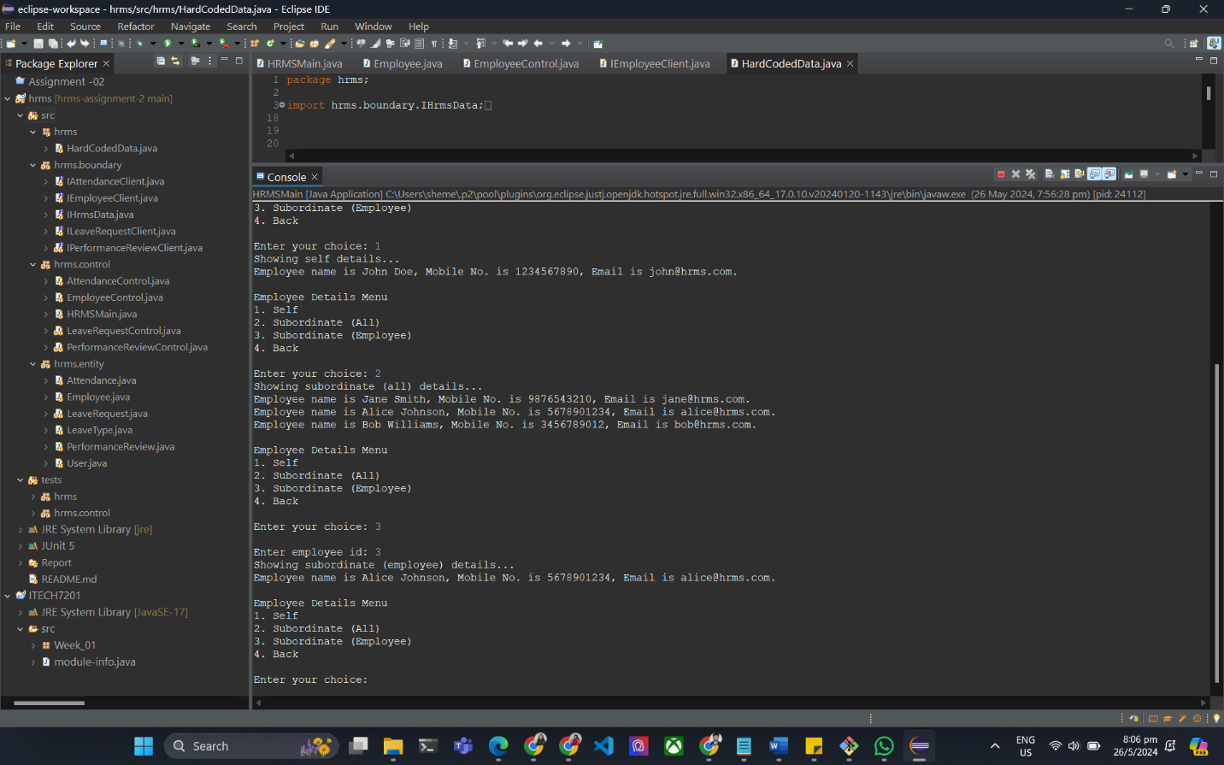

**Overview of Attendance Functionality**

The screenshots illustrate the Attendance module within the Human Resource Management System (HRMS). Upon logging in, the user is presented with a main menu offering various options, including Employee Details, Attendance, Leave, Performance, and Logout. Selecting the Attendance option leads to a submenu where users can view their own attendance details, the attendance details of all subordinates, or the attendance of a specific subordinate. This structured navigation ensures that users can access detailed attendance records efficiently.

**Viewing Self and Subordinate Attendance Details**

When the user selects "Self" in the Attendance submenu, the system displays the user's attendance records. For example, the screenshots show attendance details for John Doe, with each entry listing the attendance date, employee ID, line manager ID, status (e.g., 'Present'), clock-in time, and clock-out time. This detailed breakdown helps employees keep track of their daily attendance. Similarly, when the user opts to view "Subordinate (All)," the system provides attendance records for all subordinates under the user's supervision. This view includes details for multiple employees, such as Jane Smith, Alice Johnson, and Bob Williams, facilitating comprehensive oversight of team attendance.

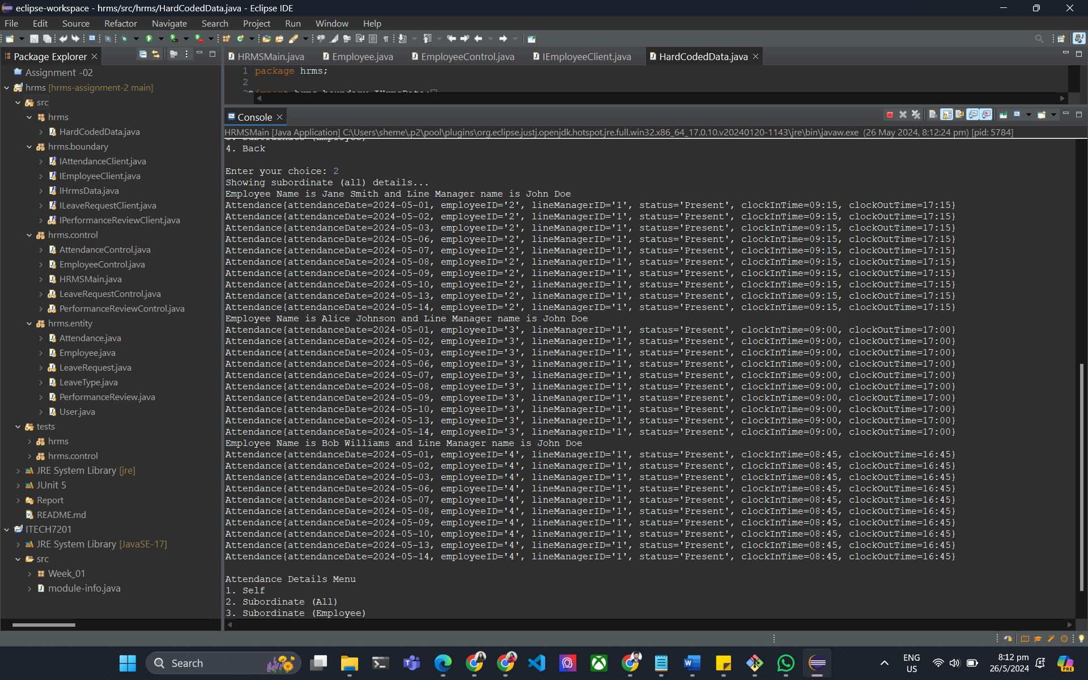

**Viewing Specific Subordinate Attendance**

The "Subordinate (Employee)" option allows the user to view the attendance details of a specific subordinate by entering the employee's ID. For instance, entering the ID for Alice Johnson displays her attendance records, including attendance dates, status, clock-in times, and clock-out times. This feature enables managers to monitor the attendance patterns of individual employees closely, identifying any irregularities or patterns that might require attention. The final option in the Attendance submenu is to go back to the main menu, ensuring that users can easily navigate back and forth between different modules within the HRMS. This functionality showcases the system's capability to provide detailed and accessible attendance tracking, essential for effective human resource management.

**Overview of Leave Functionality**

The screenshots provide a detailed view of the Leave module within the Human Resource Management System (HRMS). Upon logging in, the user is greeted with a main menu offering options such as Employee Details, Attendance, Leave, Performance, and Logout. When the Leave option is selected, the user can access a submenu that includes options for viewing leave details for "Self," "Subordinate (All)," "Subordinate (Employee)," or returning to the main menu. This setup allows for organized navigation, making it straightforward to access specific leave information based on user roles and permissions.

**Viewing Self and Subordinate Leave Details**

Selecting the "Self" option under the Leave submenu displays the leave records for the logged-in user. For example, the screenshots show leave details for John Doe, including the start date, end date, reason (e.g., 'Annual Leave'), total days, and status. This information helps users keep track of their own leave history and status. Similarly, the "Subordinate (All)" option provides a comprehensive view of leave records for all subordinates under the user's supervision. This view includes leave details for various employees, such as Bob Williams, Emma Brown, and Michael Davis, enabling supervisors to oversee and manage the leave status of their entire team effectively.

**Viewing Specific Subordinate Leave**

The "Subordinate (Employee)" option allows the user to view the leave details of a specific subordinate by entering the employee's ID. For instance, entering the ID for a subordinate provides details such as start date, end date, reason for leave, total days, and status. This functionality is useful for managers who need to monitor and approve individual leave requests, ensuring proper staffing levels and managing workload distribution. The system also indicates if there are no leave records found for a specific employee and line manager combination, as seen in one of the screenshots. This feature ensures that managers have complete and accurate information to make informed decisions regarding employee leave requests.

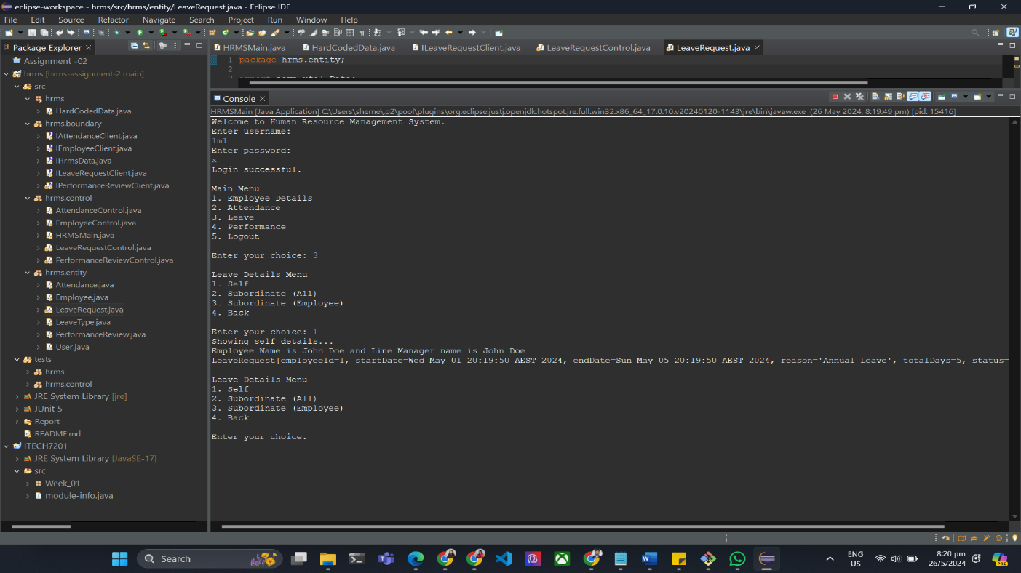

**Overview of Performance Review Functionality**

The screenshots illustrate the Performance Review module within the Human Resource Management System (HRMS). Upon successful login, the user is presented with a main menu offering several options, including Employee Details, Attendance, Leave, Performance, and Logout. Selecting the Performance option directs the user to a submenu where they can view performance reviews for "Self," "Subordinate (All)," "Subordinate (Employee)," or return to the main menu. This hierarchical structure allows users to efficiently navigate through the system to access relevant performance review data.

**Viewing Self and Subordinate Performance Reviews**

When the user selects "Self" under the Performance Review submenu, the system displays their own performance review details. For example, the screenshots show performance review information for John Doe, including employee ID, line manager ID, review date, feedback, rating, and goals. This information is essential for employees to understand their performance evaluations and areas for improvement. Similarly, selecting "Subordinate (All)" provides a comprehensive view of performance reviews for all subordinates under the user's supervision. This view includes detailed performance reviews for various employees such as Jane Smith, Alice Johnson, and Bob Williams, enabling supervisors to monitor and manage their team's performance effectively.

**Viewing Specific Subordinate Performance Reviews**

The "Subordinate (Employee)" option allows the user to view the performance review details of a specific subordinate by entering the employee's ID. For instance, entering the ID for Alice Johnson displays her performance review, including review date, feedback, rating, and goals. This targeted approach helps managers provide personalized feedback and set specific goals for individual employees. The system also indicates if there are no performance review records found for a specific employee and line manager combination, as seen in one of the screenshots. This functionality ensures that managers have detailed and accurate information to guide their team's development and performance improvement efforts.

# Consolidated class diagram

# Justification of Classes

## Class Justification

### 